**Project 2**

Name 1: Venkata Naga Datta Sai Pavan Tej Rachapudy Student ID 1: 200066810

Name 2: Kavit Maral Mehta Student ID 2: 200062954

We have three tasks in Project 2 which mainly discusses about Effects of Window Size, Maximum Segment Size and Loss Probability.

**Task 1:**

**Effect of Window Size (In this scenario Maximum Segment Size and Loss Probability is constant)**

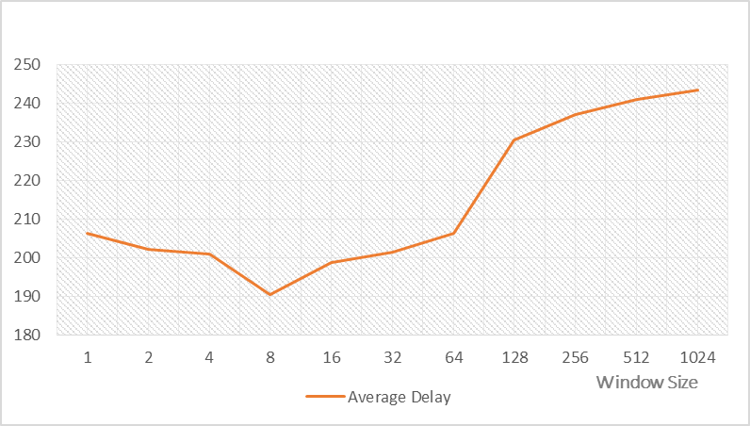

|  |  |  |  |
| --- | --- | --- | --- |
| **Window Size** | **Average Delay** | **Window Size** | **Average Delay** |
| 1 | 206.1283 | 64 | 206.3586 |
| 2 | 202.0875 | 128 | 230.3566 |
| 4 | 200.8234 | 256 | 236.8569 |
| 8 | 190.3235 | 512 | 240.8645 |
| 16 | 198.7586 | 1024 | 243.3425 |
| 32 | 201.4568 |  |  |

It is quite evident that delays are directly proportional to the size of windows. For very small window sizes like 1 and 2 the delay is less than large window sizes but greater than medium window sizes. Delay is minimum for medium window sizes between 4 and 32. For large window sizes, for every packet loss, we need to re-transmit a large number of packets which increases the file transfer time.

**Task 2:**

**Effect of Maximum Segment Size (Window Size and Loss Probability is Constant in this scenario)**

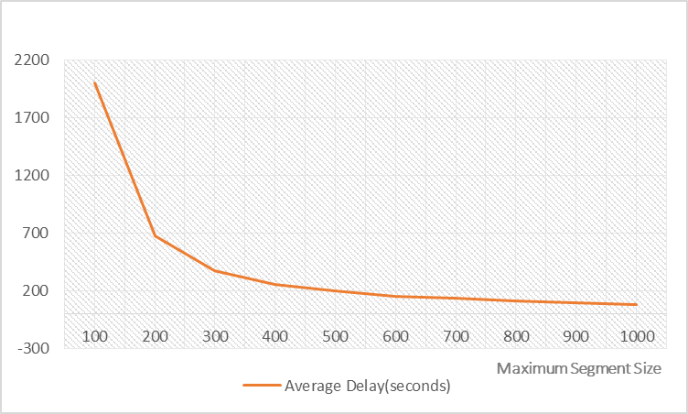

|  |  |  |  |
| --- | --- | --- | --- |
| **Maximum Segment Size(bytes)** | **Average Delay(seconds)** | **Maximum Segment Size(bytes)** | **Average Delay(seconds)** |
| 100 | 2002.9995 | 600 | 151.1234 |
| 200 | 674.9055 | 700 | 138.0986 |
| 300 | 377.1215 | 800 | 114.9867 |
| 400 | 257.9506 | 900 | 95.9867 |
| 500 | 199.1055 | 1000 | 77.9879 |

It is quite evident that delays are inversely proportional to Maximum Segment Sizes. The transfer time decreases exponentially with linear increase in Maximum Segment Size. When Maximum Segment Size is small, there are more number of packets to send, hence, packet loss is high which results in more re-transmissions which results in increase in transfer time.

**Task 3:**

**Effect of Loss Probability (Window Size and Maximum Segment Size are constant in this scenario)**

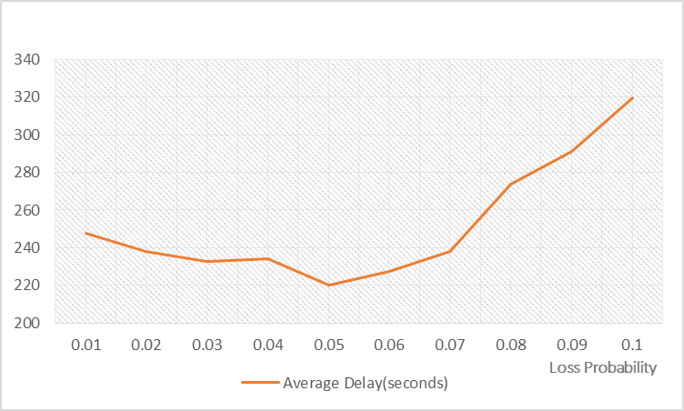

|  |  |  |  |
| --- | --- | --- | --- |
| **Loss Probability** | **Average Delay(seconds)** | **Loss Probability** | **Average Delay(seconds)** |
| 0.01 | 247.8245 | 0.06 | 227.1213 |
| 0.02 | 237.9210 | 0.07 | 237.9598 |
| 0.03 | 232.8796 | 0.08 | 273.7245 |
| 0.04 | 234.1235 | 0.09 | 290.9786 |
| 0.05 | 220.1238 | 0.1 | 319.9578 |

The average delay does not vary too much for the values of loss probability between 0.01 and 0.07. For the other values of p, the average delay is directly proportional to loss probability.